
A10
Sreenidhi Institute of Science and Technology
(An Autonomous Institution)
Code No: 111MA05
B. TECH. II-Year I-Semester Examinations, December 2015 (Supplementary)
MATHEMATICAL TOOLS FOR ECE (ECE)

Time: 3 Hours Max. Marks: 70

Note: No additional answer sheets will be provided.

Part - A
Max.Marks:20

Answer all QUESTIONS. EACH QUESTION CARRIES 2 MARKS.
- Show that 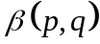 = 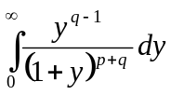
- Form the partial differential equation from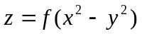
- State Cauchy’s Integral formula
- Expand 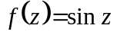in Taylor’s series about 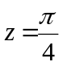
- From the following data , find value.
- Write the Lagrange’s interpolation formula for the given data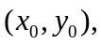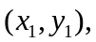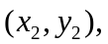………….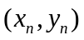
- Write the False position method to find the roots of the equation
- Write the Euler method for the solution of the problem of
- Solve for a positive root of the equation x²-3x-1=0 by Bisection Method.
- Write the Legendre's Equation.

Part – B
Max.Marks:50

ANSWER ANY FIVE QUESTIONS. EACH QUESTION CARRIES 10 MARKS.
- a) Show that 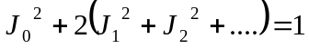
b) Show that 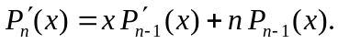

2. a) Solve 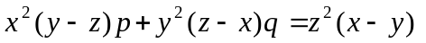
b) Solve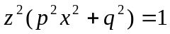

- a) If 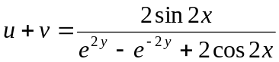, find the analytic function 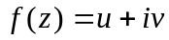
b) Evaluate 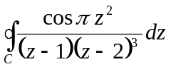, where C is 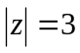 by using Cauchy integral formula
4. a) Verify the analyticity of a function
b) Construct analytic function where u=e^{x}cosy.
5. a) Find the radius of convergence of the power series 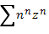
b) Obtain the Taylor Series expansion of 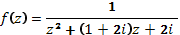 about .

6. Calculate the value of y when x=0.17 using Newton's forward interpolation formula.
x: 0 0.1 0.2 0.3 0.4 0.5
y: 1 1.1103 1.2428 1.3997 1.5836 1.7974
7. a) Represent the function f(z)=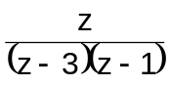 by a series of positive and negative powers of (z-1), which converges to f(z) when 0<|z-1|<2.

b) Explain Sinh z by Taylor's series about z=πi.

8. a) Use Euler's method to find y(0.2) for the given IVP y'=y+e^{x}, y(0)=0.
b) Solve the differential equation 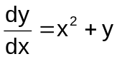, y(0)=1 by Picard's method compute y(0.02).
-- 00 -- 00 --

-- 00 -- 00 --

